**Jo Dixon, Alison Inceu, Amy Mook and Jade Ward**

**January 2021**

|  |
| --- |
| **Young People’s Summary**  York & North Yorkshire Care Leavers |
| Education Journeys |
| This summary provides an overview of the issues affecting young people leaving care in terms of their education journeys in and after care. It presents current statistics and research and draws on the views of care-experienced young people (and the professionals supporting them) to explore what can help them to have the same opportunities, aspirations and support as other young people, to achieve their career goals. Four care-experienced young people from York and North Yorkshire shared their views, alongside six members of staff. We would like to thank them all for their help and their insights..ides an overview of the experiences, issues and policies affeHeading 1On the Insert tab, the galleries include items that are designed to coordinate with the overall look of your document. You can use these galleries to insert tables, headers, footers, lists, cover pages, and other document building blocks. When you create pictures, charts, or diagrams, they also coordinate with your current document look.Heading 2 You can easily change the formatting of selected text in the document text by choosing a look for the selected text from the Quick Styles gallery on the Home tab. You can also format text directly by using the other controls on the Home tab. Most controls offer a choice of using the look from the current theme or using a format that you specify directly.  To change the overall look of your document, choose new Theme elements on the Page Layout tab. To change the looks available in the Quick Style gallery, use the Change Current Quick Style Set command. Both the Themes gallery and the Quick Styles gallery provide reset commands so that you can always restore the look of your document to the original contained in your current template.  Heading 3cting young people leaving care in terms of their education journeys and their transition to independent adulthood. It presents current statistics to help understand the group, their characteristics and experiences and draws on the perspectives of young people and the professionals supporting them to explore what can help to ensure that they have the same opportunities, aspirations and support to achieve their career goals as other young people. ides an overview of the experiences, issues and policies affeHeading 1 On the Insert tab, the galleries include items that are designed to coordinate with the overall look of your document. You can use these galleries to insert tables, headers, footers, lists, cover pages, and other document building blocks. When you create pictures, charts, or diagrams, they also coordinate with your current document look. Heading 2 You can easily change the formatting of selected text in the document text by choosing a look for the selected text from the Quick Styles gallery on the Home tab. You can also format text directly by using the other controls on the Home tab. Most controls offer a choice of using the look from the current theme or using a format that you specify directly.  To change the overall look of your document, choose new Theme elements on the Page Layout tab. To change the looks available in the Quick Style gallery, use the Change Current Quick Style Set command. Both the Themes gallery and the Quick Styles gallery provide reset commands so that you can always restore the look of your document to the original contained in your current template.  Heading 3cting young people leaving care in terms of their education journeys and their transition to independent adulthood. It presents current statistics to help understand the group, their characteristics and experiences and draws on the perspectives of young people and the professionals supporting them to explore what can help to ensure that they have the same opportunities, aspirations and support to achieve their career goals as other young people. |
|  |

|  |  |
| --- | --- |
| Introduction This executive summary was commissioned by FutureHY, the York & North Yorkshire Uni Connect partnership, to provide an overview of existing key data and to hear directly from those with lived experience of care and the professionals supporting them, about what might help or hinder journeys into education, employment and training (EET). It includes data from   * A desk-based collation of the latest relevant statistics and reference to existing research evidence on the care and leaving care populations alongside comparative data on young people generally * 1-to-1 interviews with four care-experienced young people from the two local authorities to gather first hand perspectives * 1-to-1 interviews with six professionals (leaving care services staff, Virtual Schools and University widening participation staff)  Children and young people in care and leaving care All 51 local authorities gather data on children and young people in their care (see: Department for Education (DfE) [annual statistics](https://explore-education-statistics.service.gov.uk/find-statistics/children-looked-after-in-england-including-adoptions/2020)). Introducing children in care The latest national annual snapshot reported 80,080 children in care in England (DfE 2020). Around 30,000 enter care each year, and while some return home, others remain in care. The care population is diverse with regards to their characteristics, needs and experiences (see Table A). Children and young people can legally be in care up to the age of 18.   * The majority of children in care are in foster care (72%), with a further 15% looked after in children’s homes or other residential group settings * The most common reason for a child entering care is abuse and neglect, which was the primary reason for 65% of entrants in 2020. Other reasons include family dysfunction or acute distress (22%), absent parents (6%), parental illness or disability (3%) child disability (3%) and for 1%, socially unacceptable behavior * While some children will find a settled long-term home in care, others experience instability, either moving in and out of care or moving to different care placements, with 11% moving 3 or more times in a year * The most common age-range for entering care is 10-15 (27%), with a further 20% entering aged 16 and 17. Some children, therefore, will spend very little time in care * Data for children in care in York and North Yorkshire broadly reflects the national picture. (See Tables A and B.) | “…seeing normal people can go to uni and that it’s an option. I’ve always kind of wanted to go to uni and to do that for me, I just kind of love learning things and developing my own knowledge”  (Y_NY Young Person 2020) |

### Introducing young people leaving care

Care leavers are young people from care aged 16 and over who:

* left their care placement for semi-independent or independent accommodation after the age of 16 or
* a young person in care who turns 18 and is therefore no longer legally looked after, who might have moved from their care-placement or might remain with a foster carer either on a formal basis up to age 21 (known as Staying Put) or informally as a member of their foster family

The majority of these young people will be eligible for a leaving care service from their local authority up to the age of 25, providing they were in care for at least 13 weeks since their 14th birthday, including some time after their 16th birthday. Leaving care services follow-on from the work that social workers do. This includes an allocated leaving care worker and a pathway plan to support them to move to independent adulthood. Support is holistic and needs-led, including help with finding accommodation, EET, and support to enhance their emotional, social and financial wellbeing. Other support workers include housing workers, EET workers and the virtual school to support young people in and after care.

About 11,000 young people aged 18 leave care each year in England. A further 480 are aged 17. Leaving care services currently support around 43,000 care leavers (DfE 2020). Annual data is gathered for care leavers aged 17–21 on their accommodation and their participation in EET.

Table A. Some key statistics - data snapshot for children in and leaving care in England 2020

* Semi-independent includes accommodation with support such as supported lodgings, hostels and foyers. ***Source DfE 2020***

### A brief note on policy and legislation

Caring for children living in foster care, children’s homes and care leavers is the responsibility of a wide range of professionals, including local authority children’s services social workers and leaving care workers, usually known as personal advisers (PAs).

The Children Act 1989 and Children Leaving Care Act 2000 (and their subsequent amendments) form the underpinning legislation for care-experienced children and young people. They state how children should be cared for and what support they are entitled to as children in care up to the age of 18 and as care leavers up to the age of 25. While local authority children’s services are the first port of call, the legislation also state that responsibility stretches beyond local authorities to the wider community and other agencies, departments and services, whose work might impact directly or indirectly on care-experienced young people.

“How I envision it is, obviously care leavers don’t really have parents they can rely on so the council becomes… guardians to the child and so they obviously have to provide the child with everything that their mum and dad would have provided them with. It’s important that people in care and care leavers know that that is kind of how to look at it. If you need something that your mum or dad would have provided you with, to go and ask [the council] for it.”(Y_NY care-experienced young person, 2020)

This principle of shared responsibility is known as Corporate Parenting. The principle, which since the Children and Social Work Act 2017, is embedded in law, is based on joint responsibility amongst relevant agencies to act as any good parent would by doing their best for care-experienced young people when developing and providing policies and services. In 2016 the government introduced the [Care Leaver Covenant](https://mycovenant.org.uk/?) – which asks for multi-agency sign-up by public, private and voluntary sector organisations to set out the [local offer](https://assets.publishing.service.gov.uk/government/uploads/system/uploads/attachment_data/file/683703/Local_offer_guidance_final.pdf) of what support is available for their local care-experienced young people. (See the local offers for [York](https://www.york.gov.uk/downloads/file/614/care-leavers-local-offer-booklet) and [North Yorkshire](https://www.northyorks.gov.uk/core-offer-care-leavers).)

# Experiences of leaving care

Experiences and outcomes for care-experienced young people will vary according to their pre-care, in-care and after-care circumstances. Evidence shows that for some young people, care is a positive and protective factor, whilst many others describe difficult and disrupting circumstances.

* Many care-experienced young people move to independent living much younger than other young people leave the family home

Data shows that most leave their care home aged 17 or 18. Some move into semi-independent options (supported lodgings, foyers and hostels), however, over one-third of 19-21-year-old care leavers live in their own tenancy. This compares to an average age of 28 for young people generally leaving the family home for independent living (ONS 2016).

* Care-experienced young people tend to take on the responsibilities of adulthood in a shorter space of time and without the support of parents and family

Many of the milestones and responsibilities associated with the transition to adulthood tend to coincide. For many care leavers, the priority at 18 is finding somewhere to live as many do not remain with former carers or return to families. There is also a need to establish the financial means to support their independent status (few can rely on the bank of mum and dad) and some become parents themselves, with care leavers being around three times more likely to become young parents than young people generally (Craine et al 2014).

Research also shows that care-experienced young people are at higher risk of mental health difficulties. Ford et al (2007) reported that they are five times more likely to be diagnosed with mental health needs than young people generally. This has been linked to the impact of childhood trauma and separation from family, and is reflected in the growing evidence on the impact of maltreatment on brain development, along with its effects on general wellbeing.

### Resilience

Along with the challenges that emerge from adverse childhood experiences, (such as those that brought them into care) many care-experienced young people display considerable resilience during their childhood and early adulthood in order to overcome these challenges. Furthermore, they tend to navigate the transition to adulthood and take on the accompanying responsibilities without the levels of parental support that many of their peers can expect and rely on.

“Sometimes it felt like it was my fault [but] the reason I went into care was not my fault”

(Y_NY young person 2020}

This is an important strength that carers, education providers and employers can nurture and draw on to ensure that young people can make a full, rewarding and important contribution to the local student body and the workforce of the future.

### Stereotyping and stigma

There continues to be a lack of understanding and awareness of children and young people who have been in care. Views can be distorted by negative stereotyping, which can lead to care-experienced young people feeling stigmatised.

A study of care-experienced young people carried out by the charity Coram Voice (2020), found that 1 in 8 young people in care aged 11-18 felt that adults did things which made them ‘feel embarrassed about being in care’. Furthermore, 1 in 10 felt that, as a care leaver, they have been treated worse than other young people. This reflects findings of previous research, as described by a participant in Buchanan’s 1995 study; “you say you are in care and lots of people feel sorry for you. I hate that feeling”.

# Education experiences and outcomes - what are the issues?

Adverse childhood experiences can impact on care-experienced young people’s school participation and education journeys in and after care. Research has identified factors that can protect and promote mutually positive education and care experiences.

### School

Research and national data highlight the gap between the educational attainment levels of care-experienced young people and their non-care class mates. For example, the average Attainment 8 score for York and North Yorkshire care leavers in 2019 was 23.5 and 15 respectively and 19.2 for care leavers nationally ([DfE 2019d](https://assets.publishing.service.gov.uk/government/uploads/system/uploads/attachment_data/file/884758/CLA_Outcomes_Main_Text_2019.pdf)). These compare to an average attainment level of 46.5 for all school children ([DfE 2019c](https://assets.publishing.service.gov.uk/government/uploads/system/uploads/attachment_data/file/840032/2019_KS4_Provisional_statistical_release.pdf)).

Reasons for this difference have been located in childhood trauma, placement instability as well as higher rates of school exclusions for care-experienced young people. Additionally, they are almost four times more likely to have special education needs than children in the general population (56% compared with 15%) (DfE 2020b). They are also around five times more likely to be given a fixed term exclusion than all school pupils (DfE 2017).

A number of factors located within the care experience, however, can have a positive and protective impact on education progress. For example, studies show those who enter care early and remain settled in stable foster care tend to do better in education than other care-experienced young people (Jackson et al 2003, Dixon et al 2006, Sebba et al 2015.)

### Post-18 participation

The attainment gap can have a lasting impact on EET journeys. Care leavers aged 19-21 have lower rates of participation in further education, employment, training and higher education.

Subsequently, the risk of being NEET (not in education, employment or training) is higher for care leavers. Figures for York and North Yorkshire indicate that 35% of 19-21-year-old care leavers were NEET compared to 11% of 16-24-year olds in Yorkshire and the Humber who were NEET. As noted earlier, evidence suggests entry to EET options can be delayed for care leavers while they turn their focus to where they will live after care.

Figure A. Y and NY care leavers participation in EET compared with care leavers and young people generally

Source: DfE 2020

### What are the enablers and obstacles to positive education journeys?

Evidence from practice and from research interviews with young people and support workers has identified several factors within the care experience that can negatively impact the education pathways of care-experienced children and young people. These include the impact of trauma and difficulties that led to the child’s entry to care, separation from family and home, placement instability and adjusting to new carers - all of which can be unsettling and disruptive to school experiences (See Figure B).

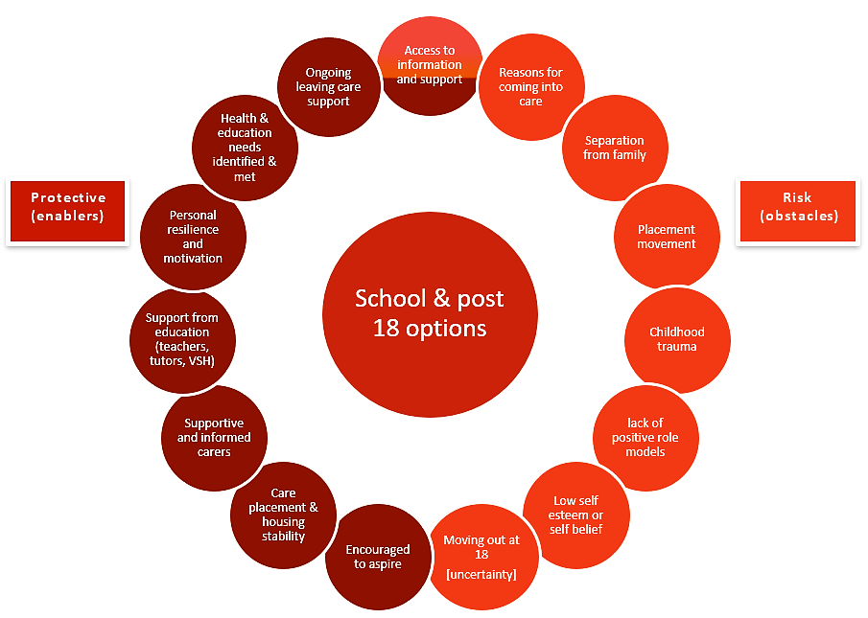 Figure B Protective and risk factors related to participation in education

As illustrated in Figure B, elements of the care experience have also been shown to be protective factors in the education experiences of children in care. These include stability in care, encouraging and supportive carers and networks, and having health and education needs met. Furthermore, international research identifies educational success as a protective factor for achieving positive outcomes in other life areas in and after care (Berlin et al 2011), demonstrating the mutual benefits of promoting positive care and education journeys. This current study and previous research also highlight the importance of young people’s self-motivation and being supported to aspire to set and achieve educational goals (Dixon et 2015).

Figure C Interplay between care and education milestones

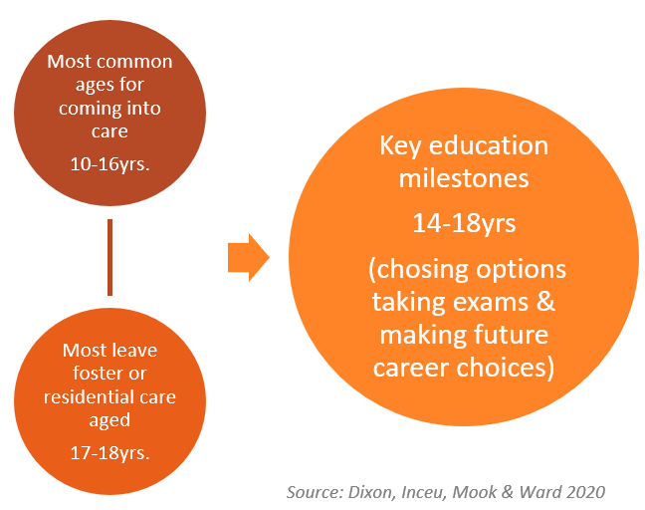

Importantly, however, it is evident from data on known characteristics of the care experience, that for some young people, key care milestones can coincide with key education milestones to interrupt their education participation and progress (see Figure C).

For example, the most common ages for entering care is 10-16, which is a crucial time in young people’s school pathway, e.g. transitioning to secondary school, choosing KS4 options and taking GCSE exams.

Similarly, the age at which compulsory education ends accords with the age at which young people legally leave care (18 years), though some leave their final care placement aged 16 or 17.

Leaving care and the uncertainty leading up to it, can therefore, coincide with other important educational milestones, such as end of school vocational or academic exams and applying for post-18 options, whether FE, HE, training or employment. The potential impact of leaving care on educational outcomes, is illustrated by one participant in Gill’s 2017 research.

[leaving care] had an effect on my emotional wellbeing and my education. When I was in foster care, I did my first year of A Levels and I got really good grades, I got like A’s, B’s, C’s. But then I moved mid A-level and you see in my second year I got like D’s, E’s, and U’s.

(Care leaver, Gill 2017)

For some care-experienced young people therefore, education opportunities and career decisions can be disrupted or put on hold whilst the focus shifts to finding somewhere to live after care. This is evidenced by research, which shows that care-experienced young people attending HE tend to be older. Harrison et al (2020) reports that over half of care-experienced young people who enter HE are aged 21 and over. Whilst there has been an increase in the range of support to enable care-experienced young people to return to their studies later, this is currently age-limited to the mid-20s and coincides with the ending of leaving care support at age 25.

# What do York and North Yorkshire young people and support staff say about obstacles to EET?

Interviews with young people and staff indicated a need for more support, information and awareness raising. Some young people stated that the professionals and the wider community did not fully understand what being in care meant for them; “I think quite a lot of people don't… understand children in care” (Y_NY young person 2020).

Staff meanwhile, noted that a lack of awareness of the range of routes into post-18 options amongst care-experienced young people, their carers and other support networks, could also pose a barrier to care-experienced young people when planning EET pathways, particularly if they did not obtain good grades at school; “not kind of realising that admissions teams take all that into account and that there's access courses and various different routes into education” (Y_NY Staff 2020).

Staff also commented that a disrupted education experience could mask young people’s true potential and abilities, and could lead to low aspirations. When coupled with limited awareness of available options, this could result in them, or professional, ruling out potential opportunities.

“Young people say that to me themselves, 'Oh, I didn't get any qualifications' and 'I just couldn't concentrate on school because I was moving’. Some of them, the qualifications ... don't match their abilities... because they're moved about. They'll move school, they'll move carers and just this interrupted education has that knock-on effect for them in that their outcomes don't really match their abilities.” *(Y_NY Staff 2020)*

A further obstacle highlighted during interviews was the impact of mental health needs on care-experienced young people’s journeys after care.

The impact of adverse childhood experiences could be exacerbated by the uncertainties of leaving care and having to set up home at an early age and without the support of family. A particular issue for young people was getting the right support at the right time.

“The hurdles that have been are my own mental health It is something that I need to get through. My leaving care worker and [education worker] are providing like counselling and things like that... phone me actually just to see how I'm doing…which I think that's quite good, and I can just kinda chat to her” (Y_NY young person 2020)

This could be difficult due to waiting lists for counselling, or Child and Adolescent Mental Health Services (CAMHS), or reaching 18 and having to transfer to adult services.

Young people noted however, that they had been able to obtain some valued emotional support from wellbeing services in their educational settings and from leaving care services. This demonstrated the importance of having someone to turn to for emotional support. Just having someone to chat to could make a huge difference, especially for young care leavers living in their own tenancies, for whom isolation and loneliness has been identified by practice and research as a worryingly common experience.

“The biggest thing is probably emotional and mental health problems, that could be just kind of feeling overwhelmed, having low confidence or low self-esteem. It could be that they have experienced a lot of trauma in their life already, so very anxious about things or feelings about being overwhelmed that they’ve got so much going on, you know education almost takes a back step because they’re just getting through the day” (*Y_NY Staff 2020)*

# Case Study

**Taylor’s journey illustrates what can help to overcome early challenges and achieve goals**

After leaving school with lower grades than expected, Taylor entered FE aged 21, whilst also working full time. After completing their FE course, they continued to work until interrupted by Covid-19 restrictions.

Taylor entered care before the age of 5 and after “loads*”* of foster placements left care aged 16 and became homeless, prior to moving into supported accommodation. Taylor felt that their care circumstances had negatively affected their education. They described being “treated differently because I was in care”. Taylor explained that they had been treated as naughty rather than being offered support from the school to cope with all they have been through. They felt that moving placements meant that they focused on where they were going to sleep that night, rather than school work; “obviously when you’re in school you need a stable, safe environment and not not knowing what's gonna happen, like … where am I gonna sleep tonight? Am I gonna be safe?”.

Taylor left school with low grades, and was concerned that going to college and finding a job was going to be difficult on their own; “a lot of people live with their mum and dad, but I don’t have that, I don’t get that support…like everyone else has company, financial help…”.

What made a difference?

Taylor explained that going to live with supported carers had been a turning point and had helped them in their education and their journey to adulthood; “they taught me everything”. Taylor described feeling settled and said that they owed everything to their supported carers, who helped them develop important life skills as well as providing stability “It wasn’t until [they] said that I could stay there permanently when I felt relief”. Being offered practical and emotional support and forming a trusted relationship with their carer at such at crucial time appeared to have finally provided Taylor with a settled base from which to focus on education and work. Taylor believes that without help and encouragement from the supported carers, local housing project and the leaving care team, they might not have been able to go to college; *“[they] got me through the door”.*

Taylor also described having a sense of determination and commitment, that was evident in them being able to study alongside working despite having to move accommodation and deal with homelessness. They felt that their resilience had helped them to find a job; *“because I wanted better in life. I didn’t want to go through any more, I just wanted my life to get better?”.*

Taylor’s advice for helping care-experienced young people with their education journeys is to;

*“Give them more support, whether its financial or one-to-one support, even just a chat, just knowing that there is someone there that you can talk to. Especially if [young people] don’t know how to approach people about their situation, if they have someone who keeps an eye on them, they’ll feel better”*

# What do young people and their support staff say about what can make a difference to young people’s journeys into EET?

The interplay between key points in the care and education experiences highlights the importance of individualised and timely support from care and education workers, carers and other services. It also indicates the importance of ongoing and wide-ranging support after care to assist the education journey, from professional and informal local support networks that understand the impact of these issues for care-experienced young people, as illustrated in Taylor’s story and the comments from young people and staff. Some of the things that helped were highlighted by young people and staff who were interviewed, and included:

#### Individualised and 1-to-1 support

Providing additional individual support at the time of moving into care and throughout young people’s education, from teachers, the Virtual School, 1-to-1 tuition and from wellbeing workers in schools featured within comments from those interviewed. This type of support was identified as being a positive and motivating factor to remain in education.

“So, I think more support as well needs to be given to the kids obviously in care that are also going through it but maybe also foster parents to know that they can’t be making decisions [about placement moves] like that off a whim, you know cause mentally and physically and everything it has a massive impact on the child” (Y_NY young person, 2020)

“We don't just focus on education, we will look at anything…get involved to identify if somebody needs some confidence-building or some self-esteem raising and get them on specific activities that will help with that, starting really back to basics” (Y_NY staff interview, 2020)

“Just have more focused work, maybe more one to one tuition if people are really struggling, things like that” *(Y_NY young person, 2020)*

#### Personal drive and aspirations

Young people’s own agency and determination to achieve their goals was also highlighted as an enabling factor for EET participation. For some, this reflected a perceived necessity to be self-reliant. More opportunities to encourage and nurture these qualities from carers, staff and other services can help more young people to develop personal motivation and aspirations.

“You have to be quite active when you’ve been in care. You have to kind of take care of yourself and work for it because you haven’t got a mum or dad saying here's this for that and you know kind of pushing you in the right direction or telling you what you should or shouldn’t do. You kind of have to work that out for yourself” (Y_NY young person, 2020)

“[Participation] does fall down to [young people’s] commitment, their resilience, their motivation. So, without dealing with those things first, they're not going to progress. So, this is where the pathway worker comes in and keeps chipping away with support” (Y_NY staff interview, 2020)

* Stable care and school experience

“Education was kind of the only thing that I felt I could control and I had that sort of power over… and it was something for me you know what I mean and I have my own autonomy to do that” (Y_NY young person, 2020)

For some young people, school was the only stable and familiar element in their lives while in care. Building on this and being mindful of how key points in the care and education experience can overlap, can help sustain participation and facilitate positive outcomes in education and other life areas.

# Comments from young people

Some understanding, which I think quite a lot of people don't have. Even during my GCSE’s it was like people didn't understand what that meant to be in care and kind of what support I needed, which was to just have more focused work, maybe more one to one tuition… if [young people] are really struggling, to understand children in care, realise that they may have issues, you know mental health and if you think they're not paying attention they might be worried about home. (Y_NY young person, 2020)

My pathway workers literally could not do anymore for me than [they] already do…just so nice and yeah literally, credit to the rest of them as well because they’re all so nice. (Y_NY young person, 2020)

I think one of the main things that children in care do is they either worry a lot.. and part of that is due to how they are feeling about themselves … but I think obviously that that needs to be kind of tackled about how they feel, kind of enlighten themselves and say look this is what I am wanting to work towards trying to create a plan you know thinking what do you want in the long run.. if that means going back to school or to college, … realistically it is never too late and I've known quite a lot people that have gone back to do their GCSE’s it's not too late. (Y_NY young person, 2020)

# Concluding summary - what can improve education journeys?

Understanding the experiences and wishes of young people in and from care is important in order to develop supportive and engaging interventions that can meet their individual needs and help them overcome obstacles to education. Extra tuition, mentoring, positive role models and providing information, advice and guidance about the range of support and EET options available, can help young people to make informed choices. Suggestions to improve education journeys include:

* Increasing young people’s knowledge of their rights and entitlements in relation to FE and HE, and improving access to careers advice to raise awareness of the range of options
* Carers and children’s services staff to increase their understanding of the range of EET options, access routes and application processes so that they can better support and advocate for their young people
* Increased awareness amongst post-18 EET providers about care-experienced young people
* 1-to-1 individualised support from a trusted and consistent adult or mentor
* Increased stability at school and in care, and reducing the impact of entering and leaving care on school/college attendance & progress (e.g. early planning to avoid placement moves during exams)
* Extra tuition to catch up on education or provide additional support during difficult times
* Opportunities to test different EET options (e.g. college taster sessions, work experience, campus tours)
* Recognising and nurturing young people’s strengths, interests and aspirations
* Longer term support – continuing beyond age 25

# Resources and information for young people

* Propel (Become) <https://www.becomecharity.org.uk/for-professionals/propel/>

Website with information on opportunities for care-experienced young people

* National Network for the Education of Care leavers (NNECL) <https://nnecl.org/>

Website with information on education opportunities for care-experienced young people

* Young People’s guide to education (Co-produced by young people & Jade Ward) <https://www.becomecharity.org.uk/media/2720/education-and-care-1.pdf>

For further information, please contact FutureHY Uni Connect: [futurehy@yorksj.ac.uk](mailto:futurehy@yorksj.ac.uk) or [jo.dixon@york.ac.uk](mailto:jo.dixon@york.ac.uk)